**Simple Machines Scavenger Hunt!**

Look around and fins as many simple machines as you can. Look closely; they are everywhere! Use the pictures below as a guide.

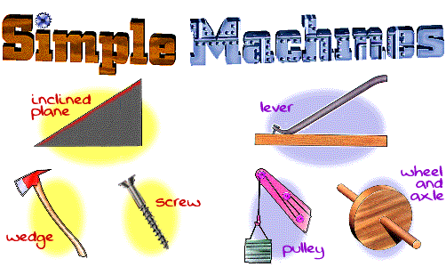

When you find a simple machine, write it down in the correct category in the table below. If you find a compound machine (one that combines more than one simple machine), record it in the compound machine row.

|  |  |
| --- | --- |
| **Simple Machine Type** | **Examples** |
| Inclined plane |  |
| Pulley |  |
| Wedge |  |
| Lever |  |
| Screw |  |
| Wheel and axle |  |
| Compound machine |  |

